Project Title
Lyrics Similarity and Attribution
Project Report submitted for the partial fulfilment of grade for the course

Data Structures and Algorithms -3 (25CS2103E)
in

A.Y. 2026-2027

Submitted by
Ch. Sricharan - 2520090019
Ganesh Agarwal-2520090052

Team Number: 16
Section: 11

Under the guidance of

Mrs.Anitha Chekuri
Assistant Professor, CS&IT
Hyderabad-500090, Telangana, India.


K L (Deemed to be) University
DEPARTMENT OF COMPUTER SCIENCE AND INFORMATION TECHNOLOGY



DECLARATION

The Mini Project Report entitled “Lyrics Similarity and Attribution” is a record of Bonafide work of Ch. SriCharan– 2520090019., Ganesh Agarwal – 2520090052, submitted in partial fulfillment for the award of B. Tech in Computer Science and Information Technology to the K L University. The results embodied in this report have not been copied from any other departments/University/Institute.

Ch. SriCharan– 2520090019
Ganesh Agarwal – 2520090052

K L (Deemed to be) University
DEPARTMENT OF COMPUTER SCIENCE AND INFORMATION TECHNOLOGY
CERTIFICATE

This is to certify that the mini project based report entitled “Lyrics Similarity and Attribution ” is a bonafide work done and submitted by Ch. SriCharan – 2520090019, GaneshAgarwal – 2520090052 in partial fulfillment of the requirements for the award of the degree of BACHELOR OF TECHNOLOGY in Department of Computer Science and Information Technology, K L (Deemed to be University), during the academic year 2026-2027.

Signature of the Supervisor

Signature of the HOD Signature of the External Examiner

ACKNOWLEDGEMENT

The success in this project would not have been possible but for the timely help and guidance rendered by many people. Our wish to express my sincere thanks to all those who has assisted us in one way or the other for the completion of my project.

Our greatest appreciation to my guide, Mrs. Anitha Chekuri, Assistant Professor, CS&IT
which cannot be expressed in words for her tremendous support, encouragement and guidance for this project.

We express our gratitude to Dr. Khaja Shareef (CSIT), Head of the Department for Computer Science and Information Technology for providing us with adequate facilities, ways and means by which we are able to complete this project-based Lab.

We thank all the members of teaching and non-teaching staff members, and also who have assisted me directly or indirectly for successful completion of this project. Finally, I sincerely thank my parents, friends and classmates for their kind help and cooperation during my work.

Ch. Sri Charan– 2520090019
Ganesh Agarwal– 2520090052

TABLE OF CONTENTS

S.No. | Contents | Page no.
1. | Abstract | 6
2. | Introduction | 7
3. | Literature survey | 8-10
4. | Problem Statement and Objectives | 11
5. | Hardware and Software requirements | 12
6. | Implementation | 13-14
7. | Results & Discussion | 15-16
8. | Conclusion & Future Scope | 17
9. | References | 18

1.ABSTRACT
The Lyrics Similarity and Attribution system is designed to analyze song lyrics and identify similarities between different songs while predicting the most likely songwriter or artist based on writing style. The system uses Natural Language Processing (NLP) techniques to process lyrical text by removing unnecessary words, extracting meaningful features, and converting the lyrics into a machine-readable format.
Using similarity measures and machine learning algorithms, the proposed system compares input lyrics with a collection of existing songs to determine how closely they match and estimates their probable authorship. This approach can help in detecting lyrical inspiration, identifying possible plagiarism, organizing music databases, and studying the unique writing patterns of different artists.
The proposed system is designed to be accurate, efficient, and easy to use. By combining text preprocessing, feature extraction, similarity analysis, and classification techniques, it provides meaningful insights into lyrical content without requiring manual comparison. Overall, the project demonstrates the practical application of Artificial Intelligence and NLP in the music domain, offering a simple and effective approach for analyzing lyrics and attributing them to their most likely creators.
Team Name:16
Team Members:
- Ch. Sricharan, 2520090019
- Ganesh Agarwal, 2520090052

- INTRODUCTION

- Song lyrics are an important form of creative expression that reflect an artist's unique writing style, vocabulary, and themes.
- Comparing a large number of song lyrics manually is difficult and time-consuming.
- The system uses Natural Language Processing (NLP) to analyze and process lyrical text.
- It removes unnecessary words and extracts meaningful features from the lyrics.
- Similarity measures are used to compare input lyrics with existing songs.
- The system also predicts the most likely songwriter or artist based on writing style.
- It can help identify lyrical inspiration and possible plagiarism.
- The project can also be useful for organizing music databases and studying artists' writing patterns.
- Overall, the system provides an automated and efficient approach for lyrics similarity analysis and attribution.

- LITERATURE SURVEY

1. Song Authorship Attribution: A Lyrics and Rhyme-Based Approach (2023)
Yılmaz and Scheffler developed a machine-learning approach to identify song artists from lyrics by analyzing character patterns, subword representations, and phoneme-level features. Their dataset contains 12,000 song lyrics from 120 artists. The research highlights how rhyme, repetition, and writing style can help distinguish artists. This work is closely related to our project’s artist-attribution feature, while our proposed baseline uses TF-IDF and supervised classification.

2. Automatic Authorship Classification for German Lyrics Using Naïve Bayes (2023)
Mendhakar and Tilmatine investigated automatic artist identification using a German lyrics corpus containing 970 songs from six artists. The study applied the Naïve Bayes classifier and compared its performance with other classification algorithms. It demonstrates that conventional machine-learning techniques can be useful for identifying authors based on lyrical text. Our project similarly uses a labeled lyrics dataset to predict the likely artist of an unknown lyric.

3. Authorship Attribution of Morsi Gameel Aziz’s Lyrics: A Clustering-Based Stylometry Approach (2021)
Omar studied disputed Arabic lyrics using a corpus of 1,089 texts and a clustering-based stylometric approach. The research used the Gibbs Sampling Dirichlet Multinomial Mixture (GSDMM) technique to group lyrics according to textual characteristics. The results illustrate how clustering and writing-style analysis can help investigate uncertain authorship. Our project explores a related problem through document similarity and supervised artist attribution.

4. Lyrics Segmentation via Bimodal Text–Audio Representation (2021)
Fell and colleagues proposed a convolutional neural network approach for segmenting song lyrics into structural sections such as verses and choruses. Their research examines repetitive patterns in lyrics and investigates how textual and audio information can complement each other. It demonstrates the importance of identifying repeated structures in song text. Our project focuses on comparing complete lyric documents rather than segmenting songs, but both approaches analyze recurring textual patterns.

5. Lyrics Segmentation: Textual Macrostructure Detection Using Convolutions (2018)
Fell and colleagues developed a convolutional neural network to identify structural sections in lyrics by learning from repeated textual patterns. The work demonstrates that computational models can detect relationships between lyric sections without relying exclusively on manual analysis. It provides useful background for analyzing repetition and structure in song lyrics. Our project uses vector-based document comparison to identify similar lyrics rather than predicting verse and chorus boundaries.

6. On Musical Stylometry—A Pattern Recognition Approach (2005)
Backer and van Kranenburg investigated musical style recognition and disputed musical authorship using statistical pattern-recognition techniques. Their experiments examined style-related features to distinguish compositions associated with different composers. Although the study focuses on musical compositions rather than lyrics, it provides background on using measurable stylistic characteristics for authorship analysis. Our project applies a related pattern-recognition principle to textual lyrics.

7. AI Music Plagiarism Detector – Open-Source Project
The AI Music Plagiarism Detector is an open-source software project that combines audio embeddings, vector similarity search, and semantic text analysis to examine potential similarities between music tracks and lyrics. Its architecture illustrates how multiple representations can be combined in a plagiarism-analysis workflow. Unlike this hybrid audio-and-text approach, our project's core functionality accepts lyric text and compares it with a reference dataset. The repository serves as an implementation reference rather than a peer-reviewed research publication.

8. Lyrics Similarity and Artist Attribution Using TF-IDF and Cosine Similarity
Traditional information-retrieval techniques represent documents as weighted term vectors and compare them using cosine similarity. In our proposed system, TF-IDF assigns weights to words based on their importance within a lyric and across the reference corpus. Cosine similarity is then used to rank reference songs by textual similarity, while a supervised classifier predicts the likely artist. This provides an interpretable baseline for lyric analysis, although word-vector similarity alone does not establish plagiarism or prove authorship.

- Problem Statement and Objectives

Problem Statement:
To develop a web-based system that analyzes song lyrics for textual similarity and predicts the likely artist using machine learning techniques.
Problem Description:
Identifying similarities between song lyrics and determining their probable artist manually is time-consuming and difficult for large collections of songs. The proposed system uses NLP and machine learning to compare lyrics, retrieve similar songs, and attribute unknown lyrics to likely artists.
Objectives:
Lyrics Analysis: To analyze song lyrics using Natural Language Processing (NLP) techniques and identify meaningful textual patterns. Song Identification: To identify the most likely song by comparing user-provided lyrics with the existing song dataset using TF-IDF and cosine similarity. Artist Attribution: To predict the possible artist of a song based on linguistic patterns and machine learning classification techniques. Music Playback and Synchronized Lyrics: To enable in-app playback of available songs and display lyrics synchronized with the playback using timestamped LRC files.

- HARDWARE AND SOFTWARE REQUIREMENTS

Hardware Requirements:
- Computer/Laptop
- Minimum 4 GB RAM
- Intel/AMD processor
- Minimum 500 MB free storage
- Keyboard and monitor
Software Requirements:
- Operating System: Windows/Linux
- Programming Language: Java
- JDK: JDK 17 or later
- IDE: VS Code / Eclipse / IntelliJ IDEA
- Terminal/Command Prompt
- No database required

- IMPLEMENTATION
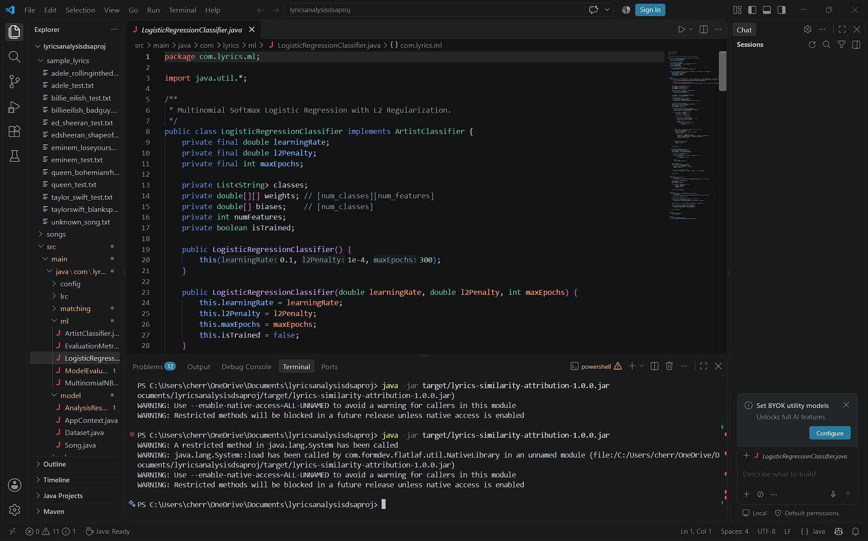
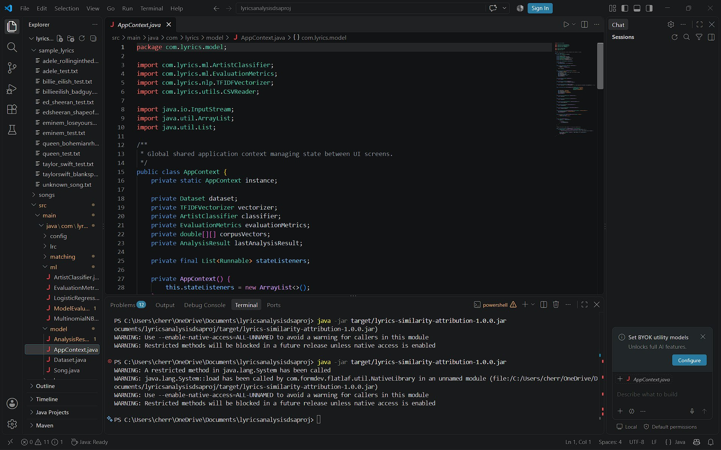

Module 1: Lyrics Dataset Management and Text Preprocessing
This module manages the reference dataset containing artist names, song titles, and lyrics. It performs text cleaning, lowercasing, punctuation removal, and whitespace normalization to prepare lyrics for analysis. The processed lyrics are stored in a structured format for further computation. This module ensures that the input data is consistent and suitable for machine-learning operations.
Module 2: Lyrics Similarity Analysis
This module identifies songs with lyrics similar to the user's input. TF-IDF converts the lyrics into numerical vectors based on the importance of words, while cosine similarity measures the similarity between these vectors. The system ranks the reference songs according to their calculated similarity scores. The output displays the most similar songs along with their artist names and similarity percentages.
Module 3: Artist Attribution Using Machine Learning
This module predicts the artist most likely associated with an unknown lyric. A supervised machine-learning model, Logistic Regression, is trained using lyrics labeled with their respective artists. The input lyrics undergo the same preprocessing and feature-extraction process used during training. The system returns the predicted artist and, when supported by the trained model, the corresponding class probabilities.
Module 4: Model Evaluation and Result Visualization
This module evaluates the artist-attribution model using a separate test dataset. It calculates performance metrics such as accuracy, precision, recall, and F1-score to measure classification performance. A confusion matrix is generated to show correct predictions and misclassifications across artists. The results are presented through the web interface to help users understand the model's performance and the reliability of its predictions.

- RESULTS & DISCUSSION
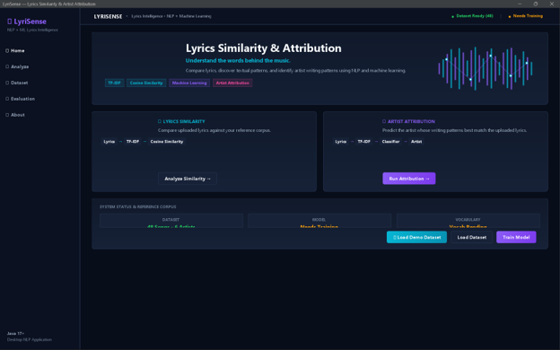
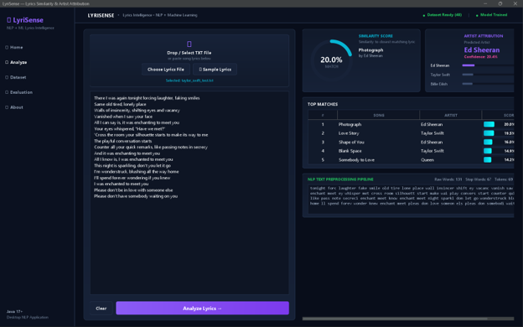
1. Home Page:
The home page displays the main features of the LyriSense application and provides navigation to the different analysis modules.It allows users to access lyrics similarity analysis, artist attribution, and dataset information.
2. Lyrics Similarity Analysis:
The system compares the input lyrics with songs in the reference dataset using TF-IDF and cosine similarity.It displays the most similar songs along with their artist names and calculated similarity scores.
3. Artist Attribution:
The system analyzes the submitted lyrics using a trained machine-learning model to predict the likely artist.The predicted artist and corresponding class probabilities are displayed as the analysis output.
4. Dataset Management:
The dataset page displays available song records containing artist names, song titles, and lyrics.This reference dataset supports similarity comparisons and provides labeled data for training the attribution model.
5. Model Evaluation:
The evaluation page displays performance metrics such as accuracy, precision, recall, and F1-score.The confusion matrix helps identify correct predictions and misclassifications made by the artist-attribution model.

8.CONCLUSION & FUTURE SCOPE
The Lyrics Similarity & Attribution project demonstrates the practical application of Data Structures and algorithms in analyzing song lyrics. The system processes lyrics and compares them using sets of unique words. HashMap, HashSet, and provide efficient methods for storing and processing the required information.
The similarity algorithm produces a percentage indicating how closely two lyrics match. By comparing the input lyrics with multiple stored songs and ranking their scores, the system can identify the most similar song and its artist.
The project provides a simple and effective demonstration of hashing, searching, sorting, string processing, and similarity analysis using Java.
- Add a larger lyrics dataset.
- Implement Cosine Similarity for improved comparison.
- Use TF-IDF to give different importance to words.
- Remove common stop words such as "the", "is", and "a".
- Add phrase-level similarity detection.
- Develop a graphical user interface.
- Add database support for storing thousands of songs.
- Provide song recommendations based on lyric similarity.
- Use advanced Natural Language Processing techniques.
- Add multilingual lyrics comparison.

- REFERENCES

1. GeeksforGeeks — Understanding TF-IDF
Explains Term Frequency–Inverse Document Frequency and how it identifies important terms in text. Relevant to: lyric feature extraction and text analysis.
https://www.geeksforgeeks.org/machine-learning/understanding-tf-idf-term-frequency-inverse-document-frequency/
2. Scikit-learn — Cosine Similarity and Pairwise Metrics
Documents cosine similarity and its use for comparing normalized text vectors.Relevant to: ranking songs against entered lyrics.
https://scikit-learn.org/stable/modules/metrics.html
3. Stanford University — Introduction to Information Retrieval
Academic reference covering the vector-space model, document representation, and similarity-based information retrieval.Relevant to: the theoretical foundation of lyrics search and ranking.
https://nlp.stanford.edu/IR-book/
4. Google for Developers — YouTube IFrame Player API
Official documentation for embedding YouTube videos and controlling playback, including seeking to a specified time.Relevant to: song playback and jumping to matching lyrictimestamps.
https://developers.google.com/youtube/iframe_api_reference
5.NLTK—Porter Stemmer Documentation
Describes the Porter stemming algorithm used to reduce word variations to common stems during text preprocessing. Relevant to: normalizing lyrics before similarity comparison.
https://www.nltk.org/api/nltk.stem.PorterStemmer.html

